SIMATS ENGINEERING (SAVEETHA SCHOOL OF ENGINEERING)
Department of Computer Science and Engineering ASSESSMENT TOOL 1 – EXPERIMENTS

Course Code: | CSA06 | Course Title: | Design and Analysis of Algorithms
CO Assessed: | CO3: Articulation (BL4, BL5) | Assessment: | Assessment Tool 1 – Experiments
Weightage: | 40% of CIA | Total Marks: | 100
CO3 Statement: | Design Divide and Conquer algorithms for Merge Sort, Quick Sort, Binary Search and Matrix Multiplication
Student Name: | Haresh Kumar N L | Reg. No.: | 192425009
Section / Batch: | AI&ML | Date: | 04/08/2026
Instructions to Students
- Answer the following question. Total Marks: 100.
- Write the algorithm and execute the code for the given experiment.
- Follow a well-structured, systematic approach to design and implement an optimal solution.
- Provide insightful analysis with accurate validation, supported by clear documentation including diagrams, code, and results.

Question Type | Focus Area | Questions
Experiments | Design and Code for Divide and Conquer Algorithms: Merge Sort, Quick Sort, Binary Search, and Matrix Multiplication | Q1

SECTION A – Experiments

Q1) Quick Sort
Evaluate the effectiveness of different pivot selection strategies in Quick Sort by implementing first, last, and random pivot techniques.
Compare their execution times under different input conditions and justify which strategy provides optimal performance, considering worst- case avoidance.


Code

of
Conduct

I

N.SRIKANTH(192411139)

certify that this submission is my original work and that I have adhered

to

the

guidelines

specified

for

this

assessment.

I

understand

that

any

violation

of

academic

integrity

rules

will result in
disciplinary action.

Signature of the

Student:

Answer:

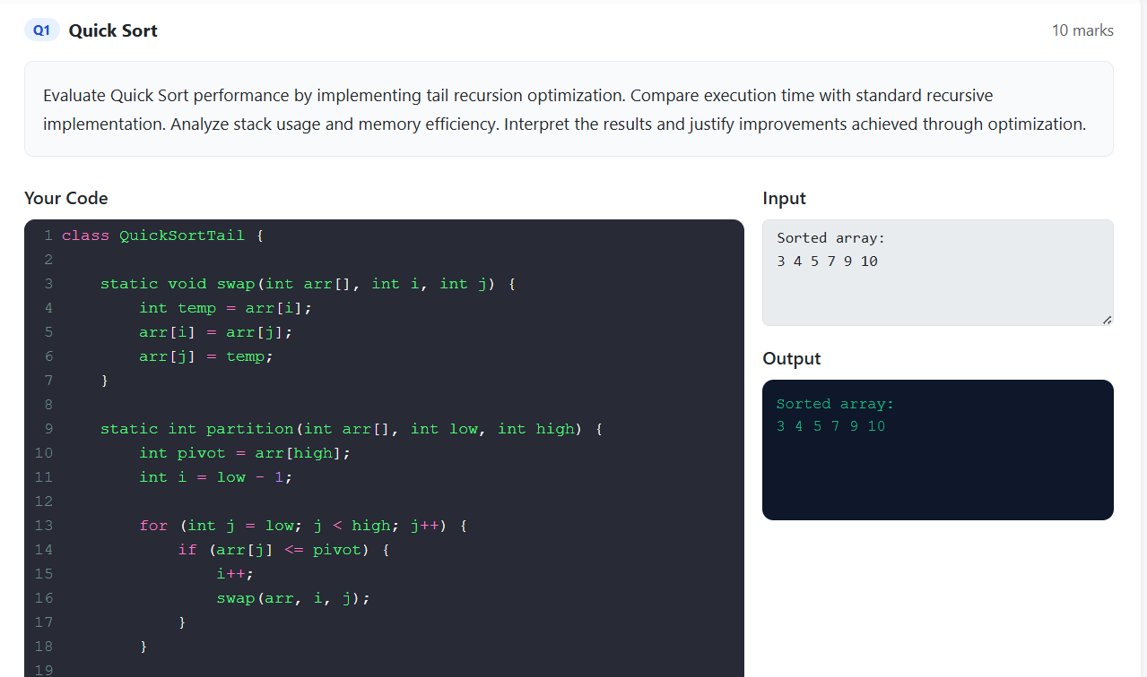

RUBRICS FOR CALCULATION

Experiments
Criteria Weightage Level 4 – Level 3 – Level 2 – Level 1 –
Exemplary Proficient Developing Beginning
Demonstrates thorough Good Basic Poor
Understa understanding and understanding understanding; understanding nding of 25% effectively integrates with proper limited or partial ; unable to
Concepts multiple integration of integration integrate concepts/technologies most concepts concepts
Well-planned, Correct Basic Incorrect or
Experime systematic implementatio implementation incomplete ntal 30% implementation with n with minor with errors or implementatio
Design optimal solution issues inefficiencies n
Effective and advanced Appropriate Limited or Incorrect or

Use of use of use of tools inconsistent use minimal use
20%
Tools tools/technologies with with correct of tools of tools
proper configuration execution
Insightful analysis with Good analysis Basic analysis Poor or incorrect

Analysis accurate interpretation with with limited analysis of results of 15% and validation of results reasonable insights
Results interpretation
Clear, well-structured Organized Basic Poor or

Documen documentation with documentation documentation incomplete
10%
tation diagrams, code, and with necessary with missing documentatio
results details details n

Marks Evaluation:
Criteria | Wt. | Level 4 –  Exemplary | Level 3 –  Proficient | Level 2 –  Developing | Level 1 –  Beginning
Understanding of Concepts | 25%
Experimental Design | 30%
Use of Tools | 20%
Analysis of Results | 15%
Documentation | 10%
Total Marks (100):

Faculty In-charge | Course Coordinator | Head of Department
Name: | Name: | Name:
Signature: | Signature: | Signature:
Date: | Date: | Date:

